CCCNGP Backplane

Hardware Design Document
Rev-A

05-Feb-2013

Ownership Disclaimer
This document contains proprietary and confidential material that is the sole property of Compressor Controls Corporation. The information contained herein is intended for internal use by Compressor Controls Corporation employees and is not intended for distribution outside of the company. As an unpublished work of trade secrets, the recipient will keep this document confidential. Any re-use, copying, or distribution, either in whole or in part, of this material without the express written consent of Compressor Controls Corporation is strictly forbidden.
Copyright © 2011 by Compressor Controls Corporation. All rights reserved.

Revision History

Rev. | Date | Revised By | Change Description
A | 05-Feb-2013 | Muthuvelu.D | First Release

Approvals

Approved by: Date: _______________

Table of Contents

1 Introduction 5
1.1 Purpose 5
1.2 Audience 5
1.3 Scope 5
1.4 Acronyms 5
1.5 References 5
2 General Description 6
2.1 Board features 6
2.2 Implementation block diagram 7
2.3 Description of functional Blocks 8
2.3.1 Power Interface to Backplane 8
2.3.2 PCC Board interface 8
2.3.3 APP Board interface 8
2.3.4 IES Board interface 8
2.3.5 IOP-AM Board interface 8
2.3.6 IOP-DM Board interface 9
2.3.7 FTA-AM Board interface 9
2.3.8 FTA-DM Board interface 9
2.3.9 External Serial Port Card interface 10
2.3.10 External TCP/IP Ethernet Card interface 10
2.3.11 ECAT board interface 10
3 Backplane Power Tree Architecture 11
4 PCB Design related 15
4.1 Placement and Layout Guidelines 15
5 Product Integration 16
Product Integration Sequence 16
Product Integration Environment 16
Product Integration Procedures and Criteria 16
6 CONNECTOR DETAILS 16

Introduction

Purpose
The purpose of this document is to describe the hardware design details of the Backplane. The document is prepared based on product requirement specifications and hardware requirement specifications prepared for Backplane.

Audience
The intended users of this document are hardware developers, software developers, test engineers, project leaders / program managers and management of Mindteck and Compressor Controls Corporation.

Scope
The scope of this document will be to describe the hardware design details of the Backplane and their supported functionalities meeting the overall system requirements.

This document describes the hardware design details of backplane, which will include connectors used on the backplane, connectors placement, interface between the various daughter cards, PCB size, layout guidelines etc. The main power input to the NGP system through the backplane power connector. The various boards namely Power Conversion Card (PCC), Application Processor (APP) board, Industrial Ethernet Switch (IES) board, I/O Processor (IOP) boards, Field Termination Card (FTA), SAC, External TCP/IP Ethernet Card (EEC) are plugged on to the backplane. These requirements are derived based on the requirements of NGP hardware system and also based on the reference documents provided by CCC.

Acronyms
Acronym | Definition
APP | Application Processor Card
NGP | New Generation Platform
PCC | Power Conversion Card
IOP | Input/Output Processor
FTA | Field Termination Card
EES | External TCP/IP Ethernet Switch
EEC | External TCP/IP Ethernet Card (EEC)
CAC | Communication Accessory Card

References
[1] Detailed Functional Specification for NGP Hardware, Part 1, Rev-3
[2] Backplane Card Hardware Requirement Specifications

General Description

Board features
Backplane will be like the backbone of the entire NGP hardware system. Even though this backplane may not be playing the major role in the functionality of the entire system, this will provide the connectivity between various boards present in the system. The backplane will be the base of the NGP hardware on which the various boards will be plugged using appropriate connectors. The various boards plugged on the backplane are PCC, APP, IES, IOP, FTA and communication accessory cards. The backplane mainly avoids the cabling between various boards for the communication between them.

The communication accessory cards will include External TCP/IP Ethernet Card (EEC) and External Serial Port Card also called as SAC.

NGP will accept the external redundant 24VDC power supplies through a 14 positions terminal block mounted on the backplane to power the entire chassis. There will be an isolated input terminal for the external redundant 24VDC that will be routed to power the analog FTA boards. Similarly there will be an isolated input terminal for the external redundant 24VDC that will be routed to power the digital FTA boards.

As mentioned the backplane supports the communication between various boards plugged onto the backplane. The major interfaces supported are the EtherCAT interface, Ethernet interface, RS485 serial interface and other digital and analog interfaces.

Implementation block diagram
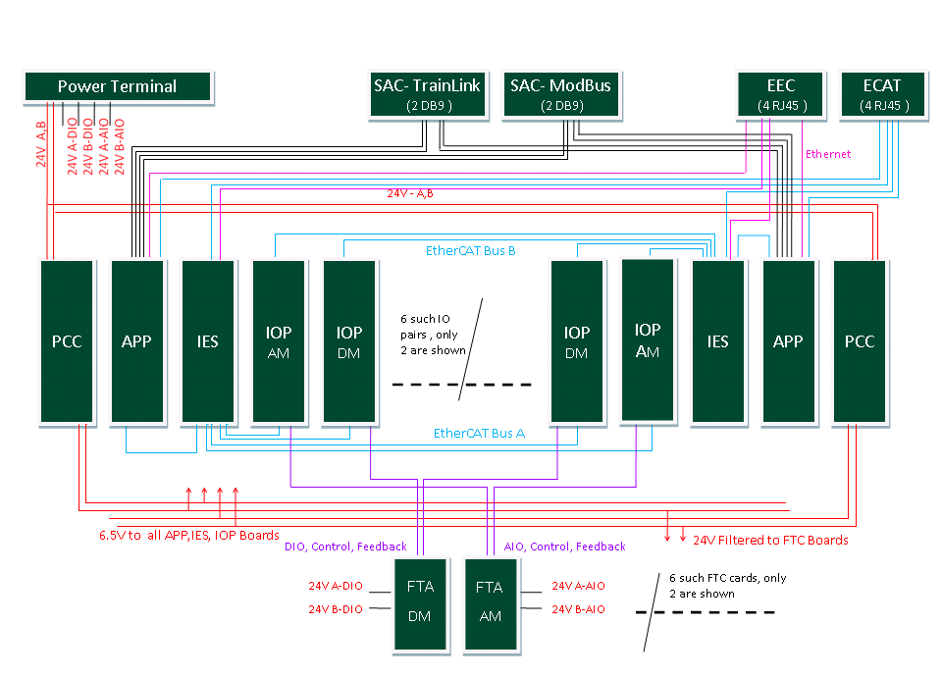

Description of functional Blocks

Power Interface to Backplane

Power connector is used to draw the power from the external power supply module. The power connector used will be 14 positions terminal block. NGP will accept the external redundant 24VDC power through this interface and supplies to all chassis cards. This connector also has isolated input terminals for external redundant 24VDC for powering the field side of Analog Input transmitters at the I/O terminals. Similarly there will be isolated input terminals for external redundant 24VDC for powering the field side of Digital I/O at the I/O terminals.

PCC Board interface

The PCC board will be plugged on the backplane through PCC board interface connector. This board receives redundant 24VDC power (range 18V-36V) and provides 6.5VDC ( 30A) output and also provides filtered 24VDC output

APP Board interface

The APP board will be plugged on the backplane through APP board interface connectors. For mounting each side APP board on the backplane two signals connectors, one power connector and two guide pins will be used.

IES Board interface

The IES board will be plugged on the backplane through IES board interface connectors. For mounting each side IES board on the backplane two signals connectors, one power connector and two guide pins will be used.

IOP-AM Board interface

There will be maximum of 6 pairs of IOP-AM boards in the NGP system. If the number of IOP-AM boards pairs used are less than 6 , then the remaining IOP pairs will be of type IOP-DM boards. Each of these IOP-AM boards will be plugged on to the backplane through IOP interface connectors.

The each of the IOP-AM board will communicate with the IES board through EtherCAT interface. There are two channels of EtherCAT from IOP-AM, one to each side of the NGP system.

For mounting each of the IOP-AM board on the backplane two signals connectors, one power connector and a guide pin will be used.

IOP-DM Board interface

There will be maximum 6 pairs of IOP-DM boards in the NGP system. If the number of IOP-DM boards pairs used are less than 6 , then the remaining IOP pairs will be of type IOP-AM boards. Each of these IOP-DM boards will be plugged onto the backplane through IOP interface connectors.

The each of the IOP-DM board will communicate with the IES board through EtherCAT interface. There are two channels of EtherCAT from IOP-DM, one to each side of the NGP system.

For mounting each of the IOP-DM board on the backplane two signals connectors, one power connector and two guide pins will be used. The signal connectors used will be of 72 pins Airmax series Press-Fit connector from FCI and the part number will be 10045271-101LF. The 4 pin power connector from FCI with part number 10028916-4554P00LF will be used to power the IES board. The guide pin used on the backplane will be 10037910-102LF from FCI.

FTA-AM Board interface

Field I/O wiring will terminate to a card called FTA, that plugs into the backplane directly without any cables. These cards will be unique to the chassis mounted I/O card that may connect to. There will be a common connector, pin out and routing from the field termination cards to I/O card backplane slots regardless of type (IOP-AM or IOP-DM).

There will be maximum of 6 FTA-AM boards in the NGP system. Each of these FTA-AM boards is plugged on to the backplane through FTA interface connector.

For mounting each of the IOP-AM board on the backplane two signals connectors will be used. The signal connectors used will be of 96 pins Airmax series Press-Fit connector from FCI and the part number will be 10052842-101LF.

FTA-DM Board interface

There will be maximum of 6 FTA-DM boards in the NGP system. Each of these FTA-DM boards will be plugged on to the backplane through FTA interface connector.

For mounting each of the IOP-DM board on the backplane two signals connectors will be used. The signal connectors used will be of 96 pins Airmax series Press-Fit connector from FCI and the part number will be 10052842-101LF.

For any FTA board the corresponding IOP board will be of same type (Analog or Digital).

External Serial Port Card interface

The external serial port card is the communication accessory card that provides connectivity from the chassis to the external devices via RS-485 communications.

There are two External Serial port cards in the system. Four full duplex RS485 channels, two from each of the APP board are terminated to each ESC. This card is called MOD BUS board. To the other ESC four half duplex RS-485 channels, two from each of the APP board are terminated. This card is called TRAIN LINK board.

In both the cases four serial ports, two from the “A” APP (Port 1A and 2A) and two from the “B” APP (Port 1B and 2B) are taken through the backplane to ESC.

For mounting each of the external serial port card on the backplane a 54 pins Airmax series Press-Fit connector from FCI will be used and the part number will be 10052842-101LF. The guide pin used on the backplane with the external serial port card will be 10037910-102LF from FCI.

External TCP/IP Ethernet Card interface

The EEC provides RJ-45 connectors for four Ethernet ports, two from the “A” APP and two from the “B” APP via backplane connector.

For mounting the EEC baord on the backplane a 54 pins Airmax series Press-Fit connector from FCI will be used and the part number will be 10052842-101LF. The guide pin used on the backplane with the external serial port card will be 10037910-102LF from FCI.

The detailed pins description is provided in the below table.

ECAT board interface

The EACT board provides RJ-45 connectors for four ECAT ports.

For mounting the EEC board on the backplane a 54 pins Airmax series Press-Fit connector from FCI will be used and the part number will be 10052842-101LF. The guide pin used on the backplane with the external serial port card will be 10037910-102LF from FCI.

The Ether CAT interface between the ECAT board and IES/APP boards is shown in the below figure.

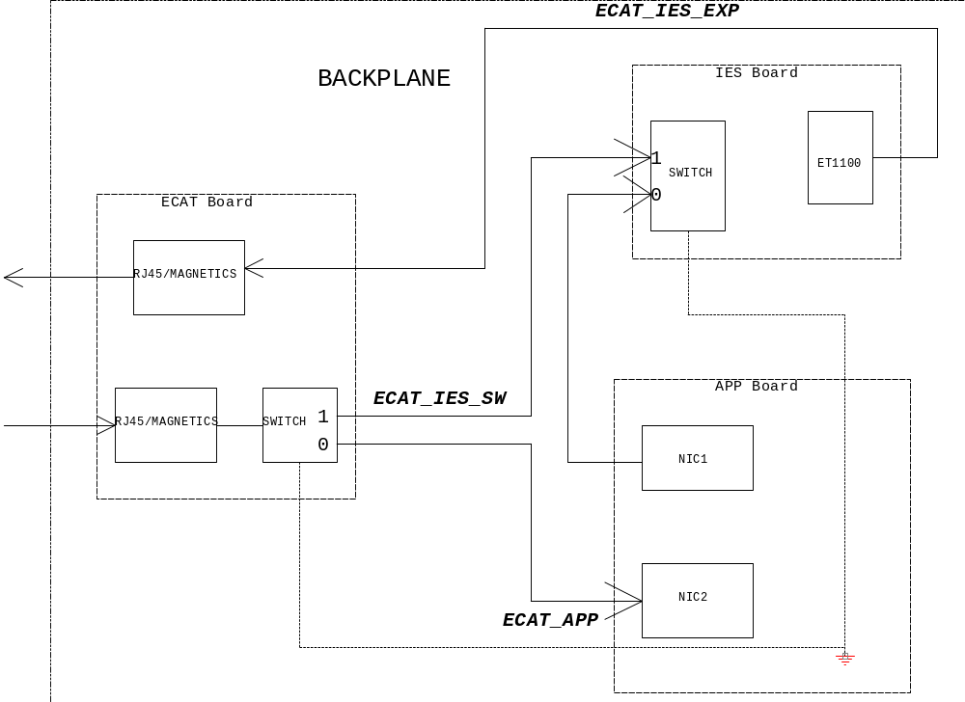

Backplane Power Tree Architecture

The external redundant 24VDC power supplies enters to the NGP Backplane though input terminals to power all chassis cards ( 24V_A and 24V_B), analog FTA/IOP section ( AIO_24V_A and AIO_24V_B) and digital FTA/IOP sections ( DIO_24V_A and DIO_24V_B) as shown in Fig 1.

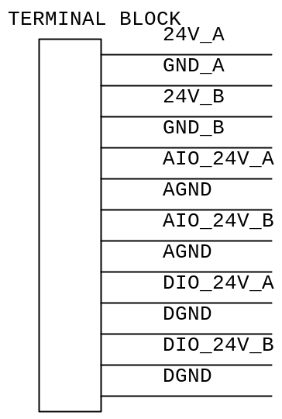

Fig . 1 : Power Terminal Block

PCC are used to generate 24V filtered power and 6.5V power as shown in Fig 2.
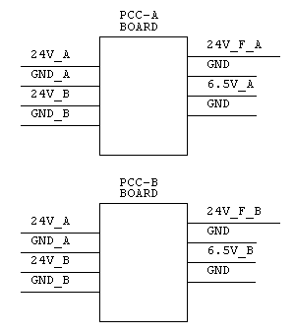

Fig 2 : PCC Board

FTA will provide the ORing functionality for various redundant 24V inputs as shown in Fig 3. The ORed single outputs are used to power the FTA (internally) and IOP boards.
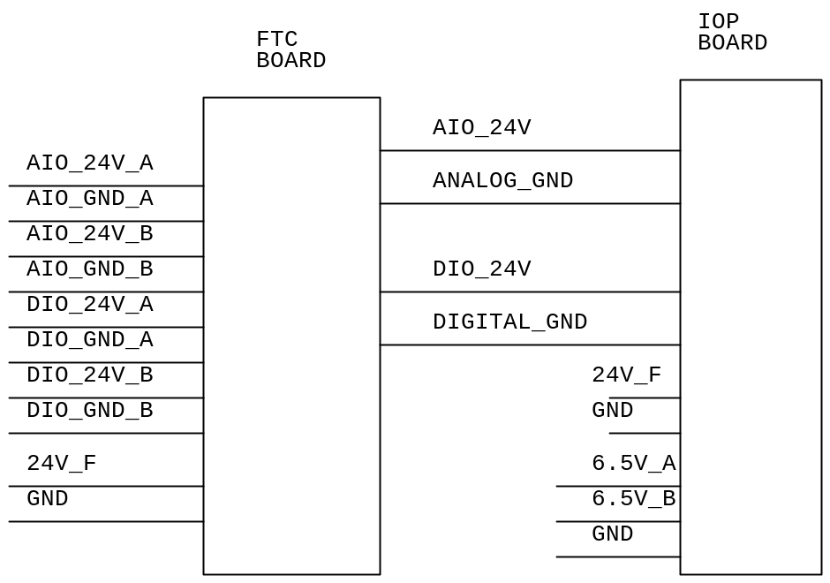

Fig 3 : IOP and FTA Boards Power

APP, IES and MOD BUS/TRAIN LINK boards provide ORing functionality of redundant 6.5V inputs as shown in Fig 4.

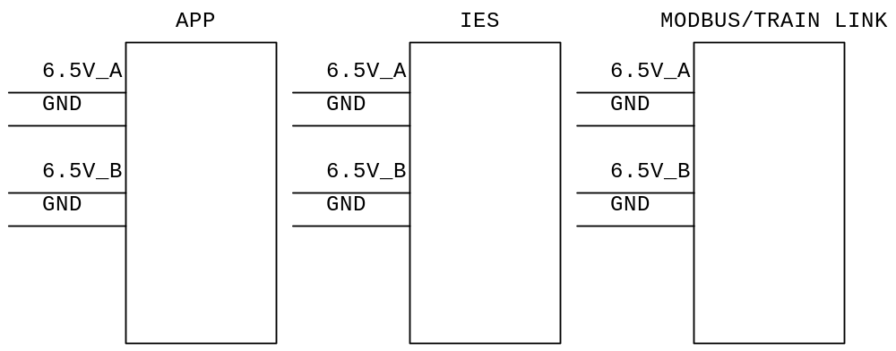

Fig 4: APP, IES and MODBUS/TRAIN LINK Boards Power
Handling Hot Swap Enable in boards with 2 connectors:

In the daughter boards ( Pluggable board) where the 2 signal connectors are used, it will be required to make sure that E4 (shortest pin) of both the connectors are used. For that the connection should be as shown in the below diagram. This makes sure that when both the connector’s short pins are connected properly, then only the Enable pin of the Hot swap controller will be triggered.

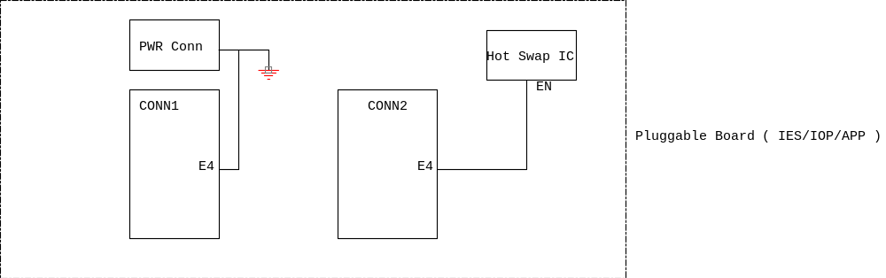

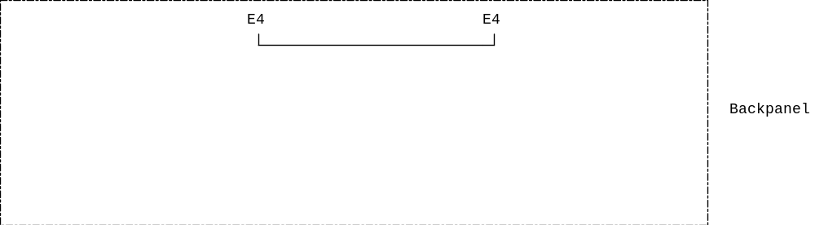

Fig 5: HOT SWAP ENABLE – SHORT PIN

PCB Design related

Placement and Layout Guidelines

- All the connectors to be placed as per the mechanical data provided in the DXF file.
- The reference pin of each connector should match with the corresponding daughter card’s same reference pin.
- Decoupling capacitors for the various power rails to be placed as close as possible to the corresponding pins of the power connector.
- Differential pair (TX+/- or RX+/-) should be routed away from all other signals and close together to meet the trace width and trace space as given in the stack up details.
- Route each differential pair on the same PCB layer.
- Keep both traces of each differential pair as identical to each other as possible.
- Ensure that all the critical signals should have an unbroken reference ground plane.
- Avoid via and pad in the path on any critical signal as via and pad will induce unwanted capacitance and inductance which can cause reflection and distortion.
- Ensure the various power signals have enough trace width to carry the required current. 24V_A and 24V_B should carry 48A , 6.5V_A and 6.5V_b should carry up to 36A and each of 24V_DIO_A, 24V_DIO_B, 24V_AIO-A and 24V_AIO_B should be able to carry 6A current.

Product Integration

Product Integration Sequence

After backplane assembly and basic hardware testing the backplane will be fixed to the mechanical enclosure. The various daughter boards can be fixed on to the corresponding position on the backplane.

Product Integration Environment

Under normal lab conditions

Product Integration Procedures and Criteria

Under normal lab conditions, precautions should be taken for ESD while handling the printed circuit board assembly.

CONNECTOR DETAILS

Please find embedded document for detailed board to board connector details

